|  |  |  |  |  |  |
| --- | --- | --- | --- | --- | --- |
| Date | 29-Nov-22 | | | Tester Name | Andrew McLaughlin |
| Environment | Penfax - Test | | | Login used |  |
| Operating System | Select OS | Version: | Update: | | |
| Software Used | Select Software | Version: | Update: | | |
| Select Software | Version: | Update: | | |
| Release version | 22.4.1 | | | | |
| Title | Death – Member Age 65 Reduction Date Correct | | | | |
| Test Type | Regression | | | | |
| Test Scenario | Death – Member Age 65 Reduction Date Correct | | | | |
|  |  | | | | |
| Expected Results | When a pensioner with a bridge dies before their 65th birthday with a joint annuitant, their remaining payments should be paid out to the joint annuitant until the reduction date (end of month that member turns 65).   * We should be able to transfer the income benefit to the joint annuitant with an expiration date equal to the end of the month that the member would turn 65. * After the month the member would turn 65, the bridge should drop off. | | | | |
| Pass/Fail | Pass | | | JIRA# | N/A |

Describe your steps with screenshots:

Member is with MEPP and has a bridge 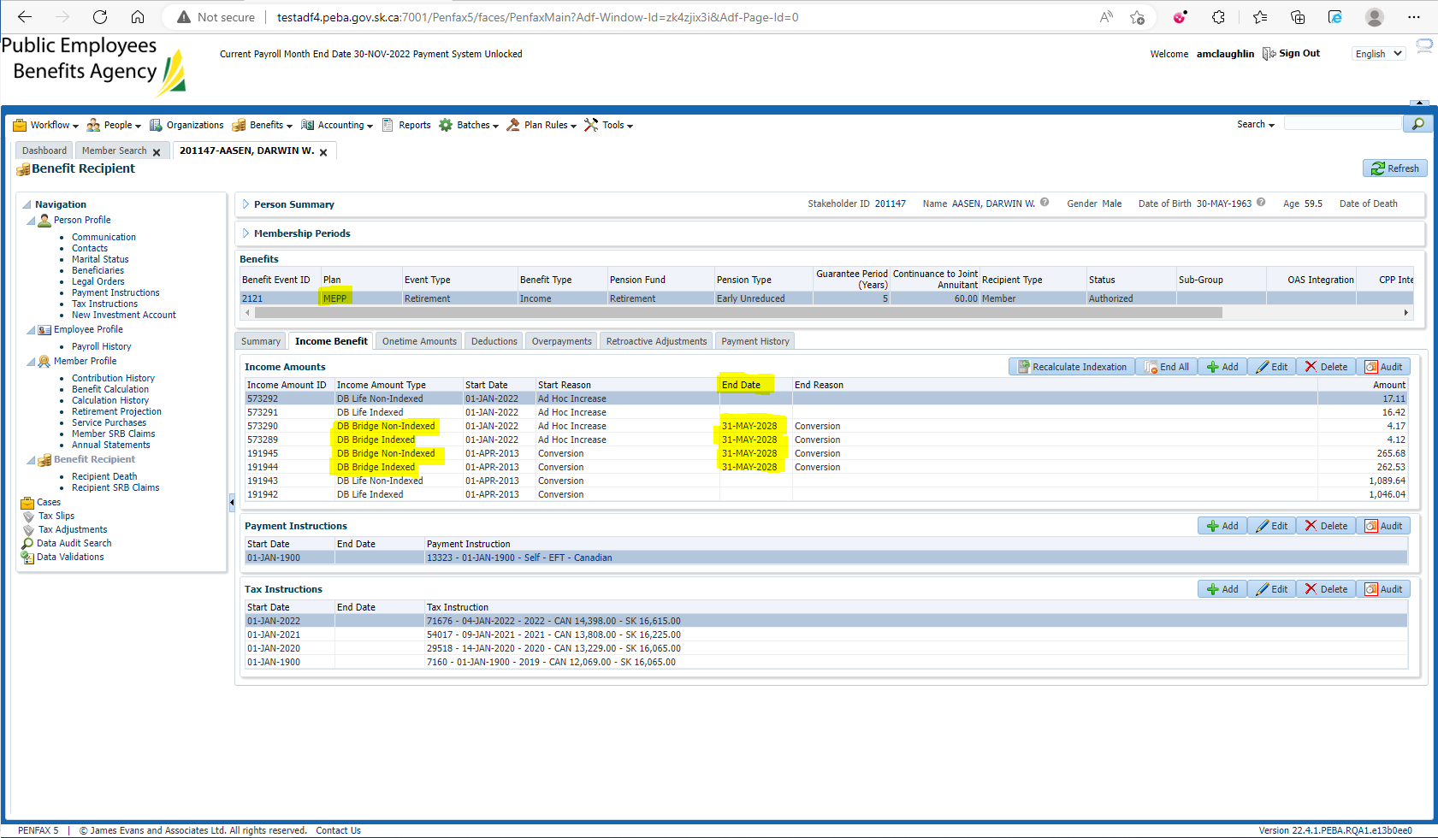

Pension amount is $2,705.71 with a 60% JA. GP Expired 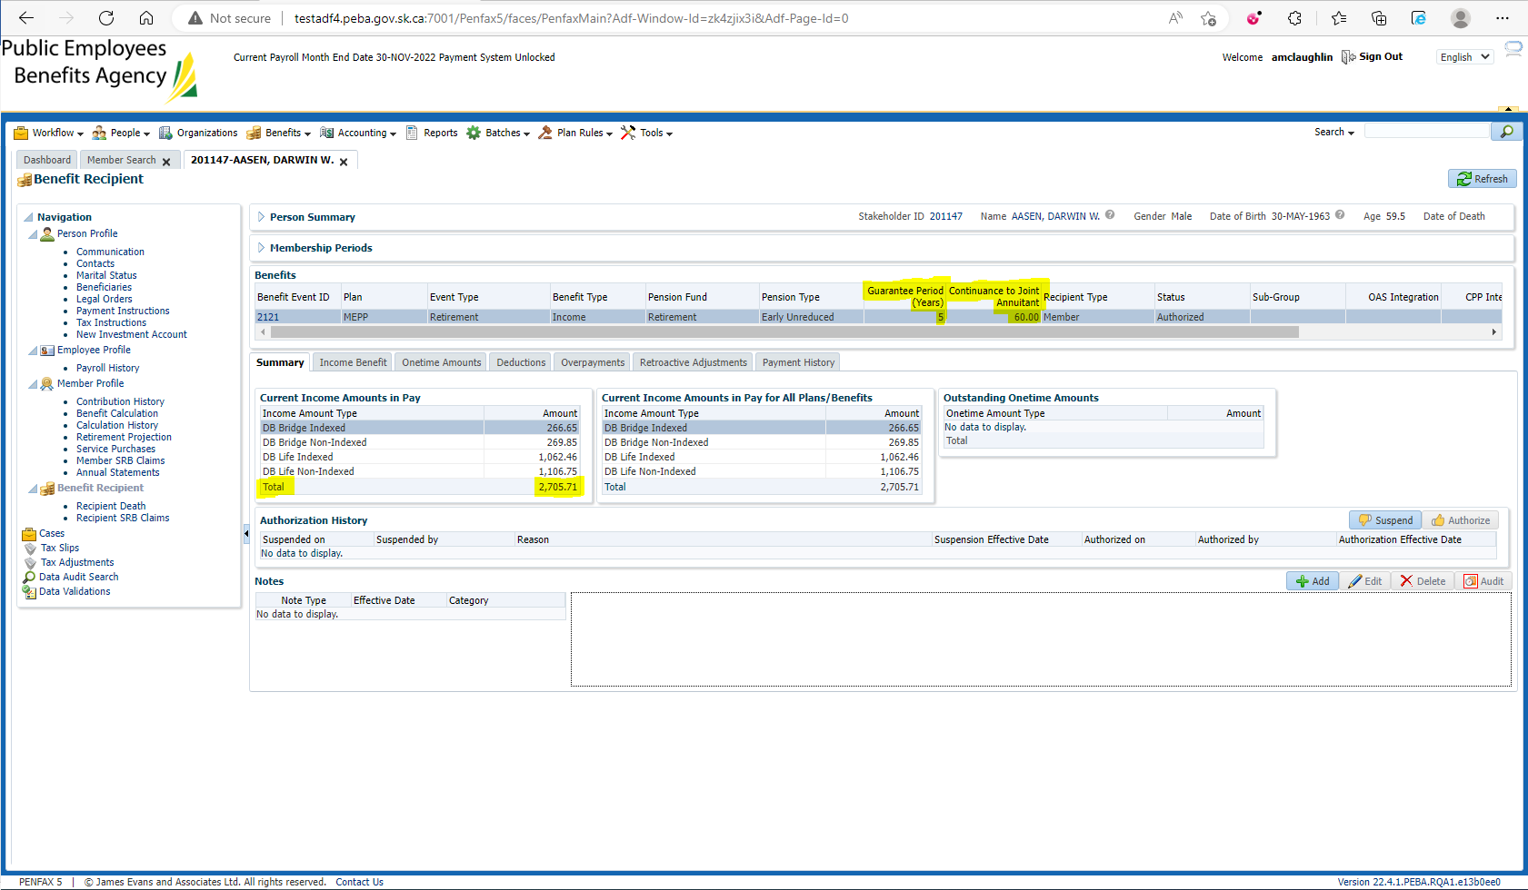

Enter Death Date 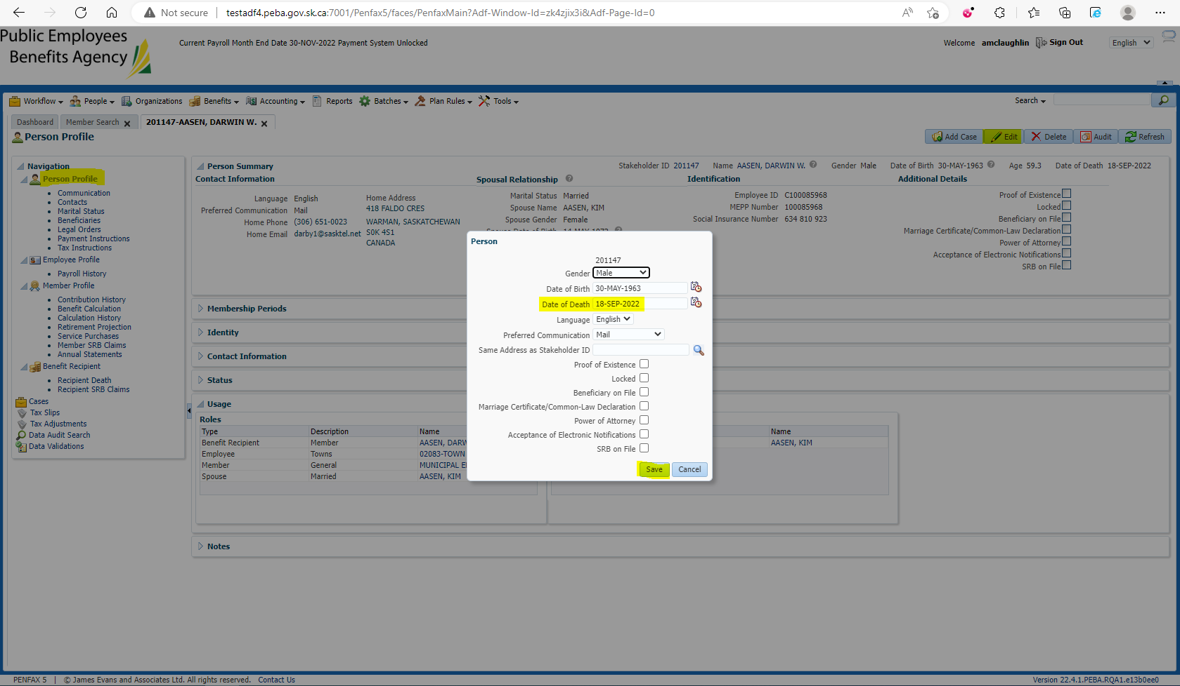

Add the spouse to the Benefit Recipients in the Benefit Event effective 1st day of month after death 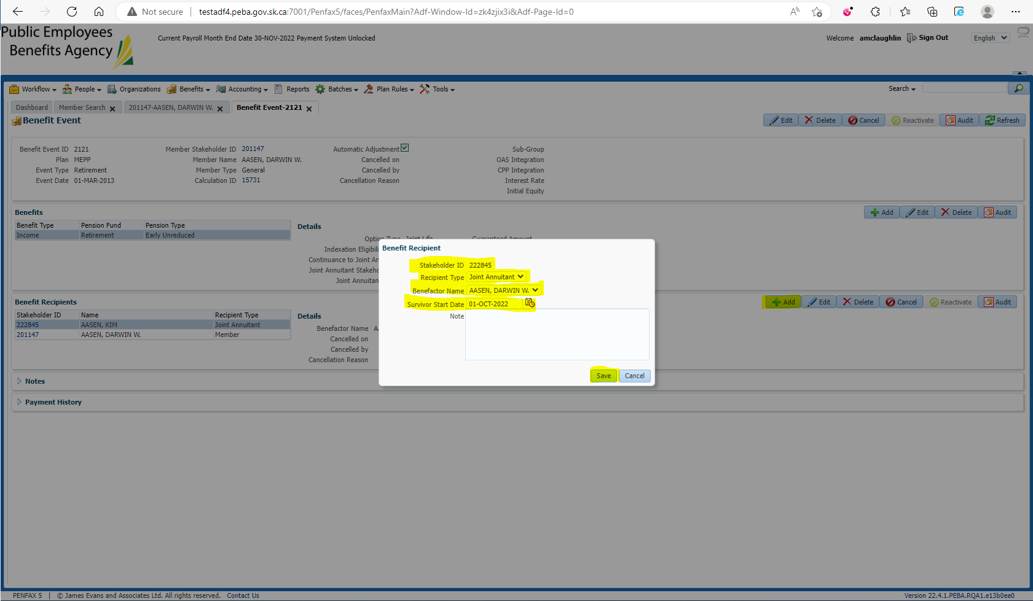

Open the Death Calc 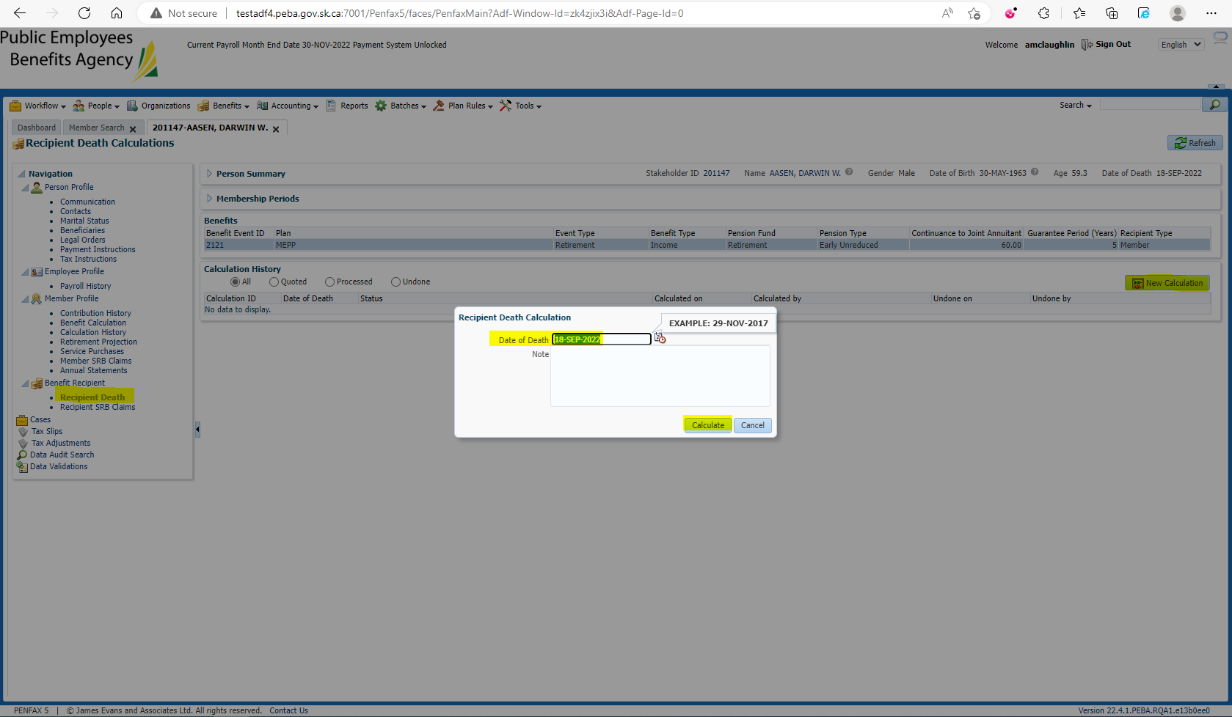

Process x2 and Process Recipient x2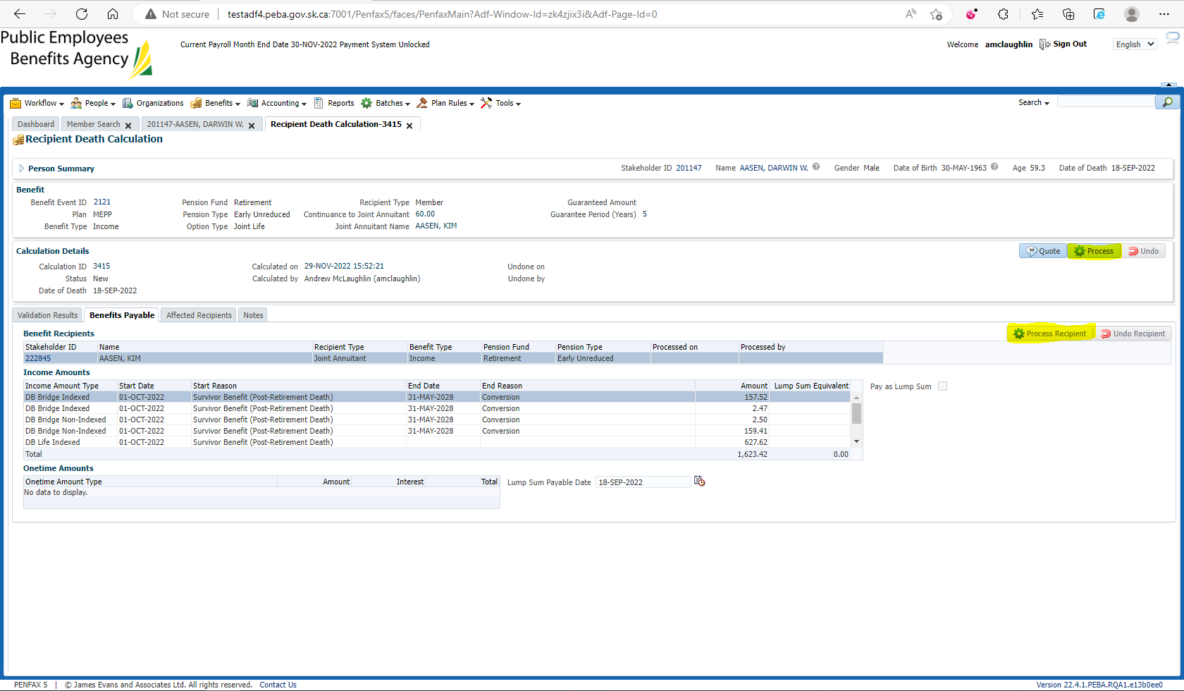

Verify under the spouse’s Benefit Recipient that the Bridge End Dates stay the same 